Question 1

Write an SQL Query to find for each user, the join date and the number of orders they made as a buyer in 2019.

Return the result table in any order.

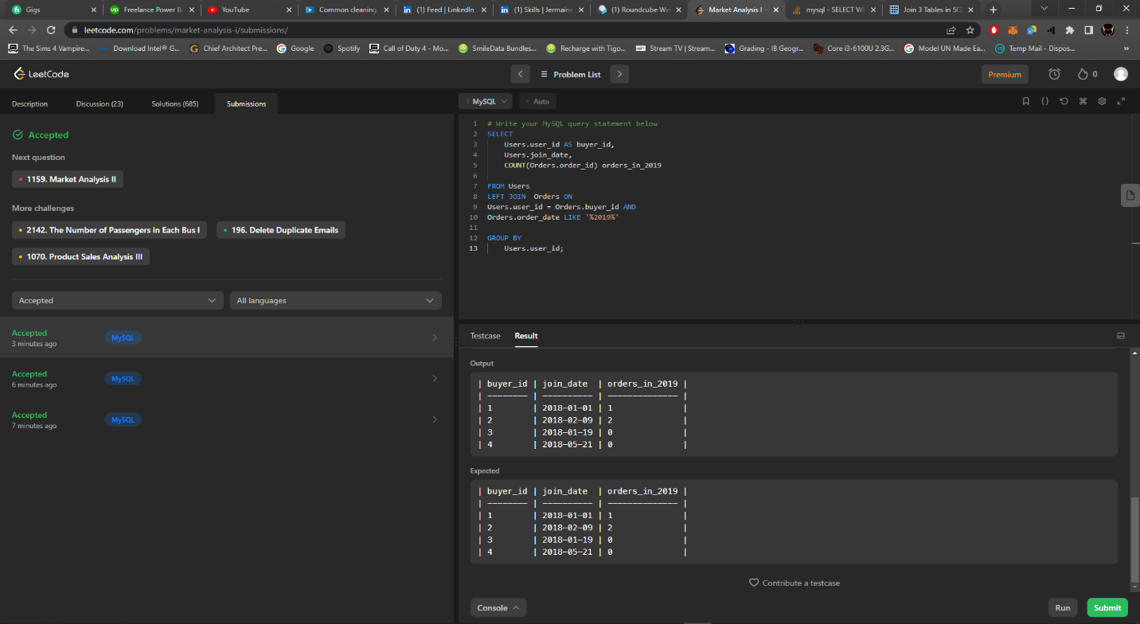

Solution for Question 1

Question 2

Write an SQL query to report the Capital gain/loss for each stock.

The Capital gain/loss of a stock is the total gain or loss after buying and selling the stock one or many times.

Return the result table in any order.

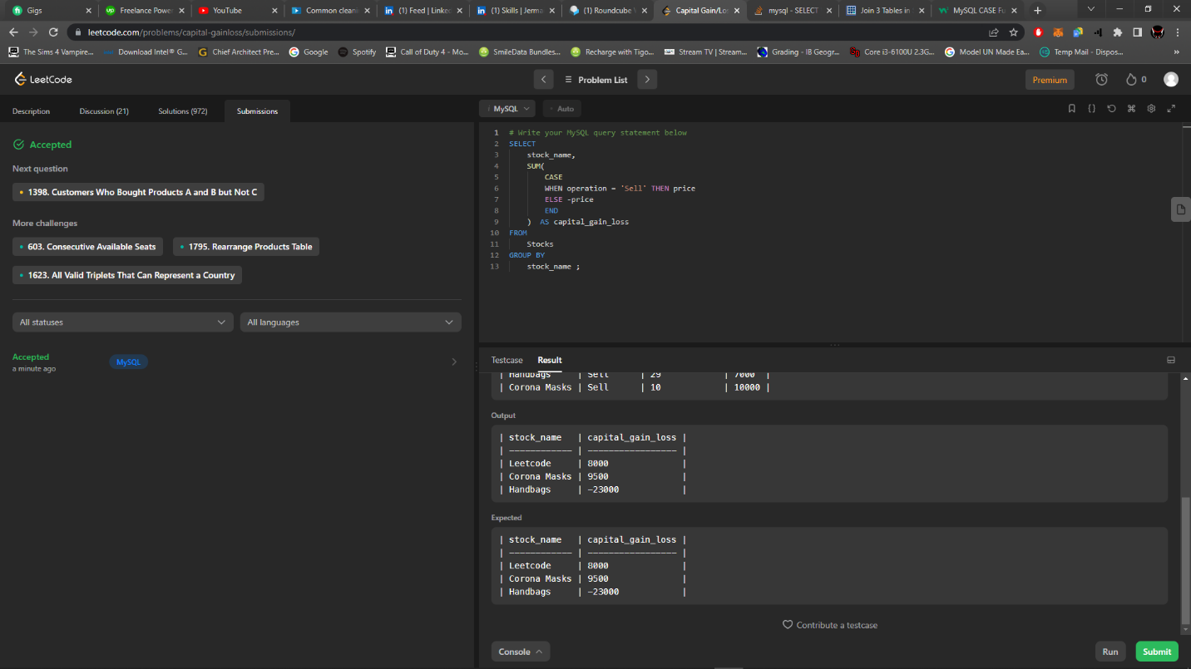

Solution for Question 2